**CONSTANTS AND MACROS**

**1. Write a function macro to find the smallest number in an array of integers**

**OUTPUT:**



**2. What are the differences between macros and constant. Can you replace a constant with a macro and vice versa? Give examples for your statements**

**Macro:** A macro is a preprocessor directive that defines a name to represent a piece of code, usually a value or expression, and gets replaced by the preprocessor before the program is compiled.

* **Defined using #define.**

**Constant:** A constant is a variable that cannot be modified once it is initialized. It is a type-safe feature and is part of the program during runtime.

* **Defined using const.**

**OUTPUT:**

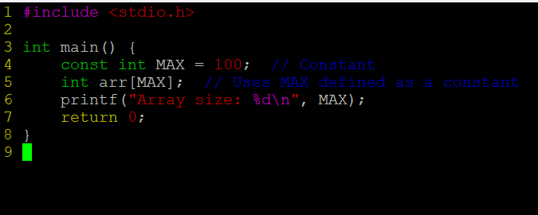

**OUTPUT:**



**3. Refer macro below**

**#define MYPROD(x) (x *x)**

**WAP to invoke the above macro with inputs as below and display the result.**

**a. MYPROD(2+1)**

**b. MYPROD(6+1)**

**Do you get the expected answers as 9 and 49 in case a. and case b.?**

**If not modify the code to produce the expected results. in above case**

**A: Modified code:**

**OUTPUT:**

**4. Write macro definitions with arguments for calculation of area of a triangle and circle.**

**a. Use macros for both constants as well as formula evaluations.**

**b. Store these macro definitions in a header file and invoke the macros from the main function.**

**HEADER FILE:**

**MAIN FILE:**

**OUTPUT:**

**5. Define a macro name MYPRINT as below.**

**#define MYPRINT(x) printf(x)**

**Use the above macro conditionally only if a macro CUST_PRINT is defined , otherwise not to be used.**

**For eg refer the code and comments below.**

**int main()**

**{**

**MYPRINT("Hello World"); // will be displayed only when CUST_PRINT is defined**

**printf("Test"); // will be displayed always irrepective of CUST_PRINT**

**return 0;**

**}**

**Add the code to demonstrate the above behaviour.**

**OUTPUT;**



**6. Identify and use the macros to display**

**a. file name**

**b. function name**

**c. line of code**

**Show the usage with a code example**

**OUTPUT:**

